Group 1: Tung Pham, Ngoc Nguyen, Rebecca De Venezia, Lucas March

**Project Summary**

* The project aims to assess all the possible trips that can be made from one location to another, while taking different external variables/factors into account.
* Our project scope includes all cities in Canada and the United States.
* A model corresponds to all possible trips that can be made given that all the constraints are satisfied. The constraints, of course, will greatly narrow down the amount of ways to make such a trip; and include factors such as weather, roadwork, etc.
* The three forms of transportations that we are using are: drive, transit (train) and plane.
* We are using the city datasets found at **simplemaps.com**

**Propositions**

* Weather:
  + Sunnyi,j = True if the weather is sunny when travelling from location i to location j
  + Rainyi,j = True if the weather is sunny when travelling from location i to location j
  + Snowstormi,j = True if the weather is sunny when travelling from location i to location j
* Means of transportation:
  + Drivei,j = True if driving is the method of transportation from location i to location j (note that by driving we only allow 5-seated cars).
  + Transiti,j = True if Transit is the method of transportation from location i to location j
  + Planei,j = True if plane is the method of transportation from location i to location j
* External factors:
  + Virus = True if the person/persons have the virus
  + Documents = True if the person/persons have travelling documents
  + International = True if the trip is international
  + Holiday= True the trip is during a holiday
  + Toll_Money= True if the person/persons have money to pay for toll fees
  + More_Than_Five= True if there are more than five people travelling at a time
  + Afford_Plane = True if the person/persons have enough money to pay for plane tickets
  + Urgent_Trip = True if the user wants the fastest route (note that an urgent trip will not be possible if other constraints prevent the fastest mode of transportation from being viable).
  + Roadworki,j = True if there is a roadwork/construction when travelling from location i to location j
  + Accidentsi,j = True the trip from location i to location j involves an accident along the way
  + Tolli,j = True if the trip from location i to location j have a toll

**Constraints**

**(we use implication here for clarity, but, in the code, we only use NNFs and CNFs)**

* At least one state of weather has to hold when travelling from one place to another
  + Sunnyi,j ∨ Rainyi,j ∨ Snowstormi,j
* Weather constraints:
  + If it is sunny, it cannot be rainy or a snowstorm:
    - (Sunnyi,j → ¬ Rainyi,j ∧ ¬ Snowstormi,j)
  + If it is rainy, it cannot be sunny or a snowstorm
    - (Rainyi,j → ¬ Sunnyi,j ∧ ¬ Snowstormi,j)
  + If there is a snowstorm, it cannot be sunny or rainy
    - (Rainyi,j → ¬ Sunnyi,j ∧ ¬ Rainy,j)
  + Good weather and holiday imply that tickets will be sold out and you must drive
    - Sunnyi,j ∧ Holiday → ¬ (Transiti,j ∨ Planei,j)
  + Rainy or snowstorm increases the likelihood of accidents
    - Rainyi,j  ∨ Snowstormi,j → Accidentsi,j
  + Snowstorm implies that transit and planes will be shut down
    - Snowstormi,j → ¬ Transiti,j ∧ ¬ Planei,j
* Driving constraints: **drive will only be considered as an option if the travelling time is less than 24 hours (reasonable assumptions)**
  + Bad weather and roadwork imply unfeasible trip
    - (Rainyi,j ∨ Snowstormi,j) ∧ Roadworki,j  →¬ Drivei,j
  + Bad weather and holiday imply unfeasible trip
    - (Rainyi,j ∨ Snowstormi,j) ∧ Holiday → ¬ Drivei,j
  + Roadwork and holiday imply unfeasible trip
    - Roadworki,j ∧ Holiday → ¬ Drivei,j
  + Roadwork and accident imply unfeasible trip
    - Roadworki,j ∧ Accidentsi,j → ¬ Drivei,j
  + Holiday and accident imply unfeasible trip
    - Holiday ∧ Accidentsi,j → ¬ Drivei,j
  + You cannot drive anywhere if you have more than 5 people
    - ¬ Drivei,j ∨ ¬ More_Than_Five
  + If it would take more than 3 hours to drive to/from this trip or the trip is international, tolls will be there. You cannot cross a toll if you have no toll money
    - Tolli,j ∧ ¬ Toll_Money→ ¬ Drivei,j
    - International→ Toll,j
* Transit constraints: **Transit will only be considered as an option if the travelling time is less than 10 hours (reasonable assumptions)**
  + Good weather and holiday implies Transit tickets will be sold out
    - ¬ (Sunnyi,j ∧ Holiday) ∨ ¬Transiti,j
  + Snowstorm implies that Transits will be shut down
    - ¬ Snowstormi,j ∨ ¬ Transiti,j
* Plane constraints: **plane will only be considered as an option if the travelling time is greater than 2 hours (reasonable assumptions)**
  + You cannot take a plane if you don’t have money for a plane ticket
    - Afford_Plane ∨ ¬ Planei,j
  + Good weather and holiday implies plane tickets will be sold out
    - ¬ (Sunnyi,j ∧ Holiday) ∨ ¬ Planei,j
  + Snowstorm implies that planes will be shut down
    - ¬ Snowstormi,j ∨ ¬ Planei,j
  + If you have the virus, you can’t take the plane
    - ¬ Planei,j ∧ (¬Virus ∧ Documents)
  + If you don’t have documents (passport), you can’t take the plane
    - Documents ∧ ¬ Planei,j
* You must have at least one form of travel
  + Drivei,j ∨ Transiti,j ∨ Planei,j
* Only one form of travel can be true at once
  + Drivei,j → ¬ (Transiti,j ∨ Planei,j)
  + Transiti,j → ¬ (Drivei,j ∨ Planei,j)
  + Planei,j → ¬ (Transiti,j ∨ Drivei,j)
* When travelling internationally:
  + You have tested positive for the virus/been in contact, you cannot cross the border
    - ¬International ∨ (¬Virus ∧ Documents)
  + No documents mean you cannot cross the border
    - (International ∧ Documents) ∨ ¬International
* If you are taking an urgent trip, only the fastest mode of travel is possible
  + If Drivei,j is the fastest route
    - ¬Urgent_Trip ∨ (¬ Planei,j ∧¬Transiti,j)
  + If Transiti,j is the fastest route
    - ¬Urgent_Trip ∨ (¬ Planei,j ∧¬ Drivei,j)
  + If Planei,j is the fastest route
    - ¬Urgent_Trip ∨ (¬ Drivei,j ∧¬Transiti,j)

**Model Exploration**

* Solutions for our project are settings of True/False propositions that correspond to a feasible trip from one place to another (that is, constraints don’t prevent the trip from being made).
* As an interesting touch on the project, we added a user-input prompt so that they can enter where they want to begin and end their trip. The program then gives them a choice of 10 stops to take along the way, and the user can choose as many or as little stops as they would like. The user can also specify if they want to take the fastest trip or not (an urgent trip will give you the fastest route).
* Before we walk you through the journey of working on this model, here is the output of the final product. Note that if multiple cities with the same name exist in a country, the user can also clarify this:

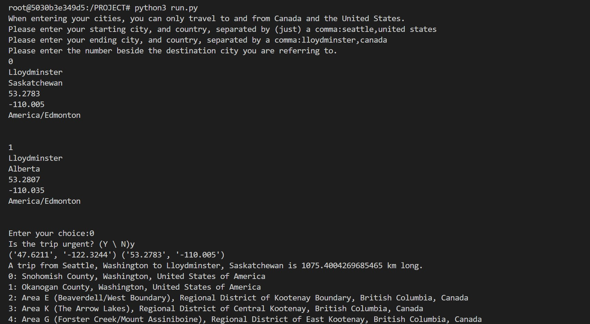

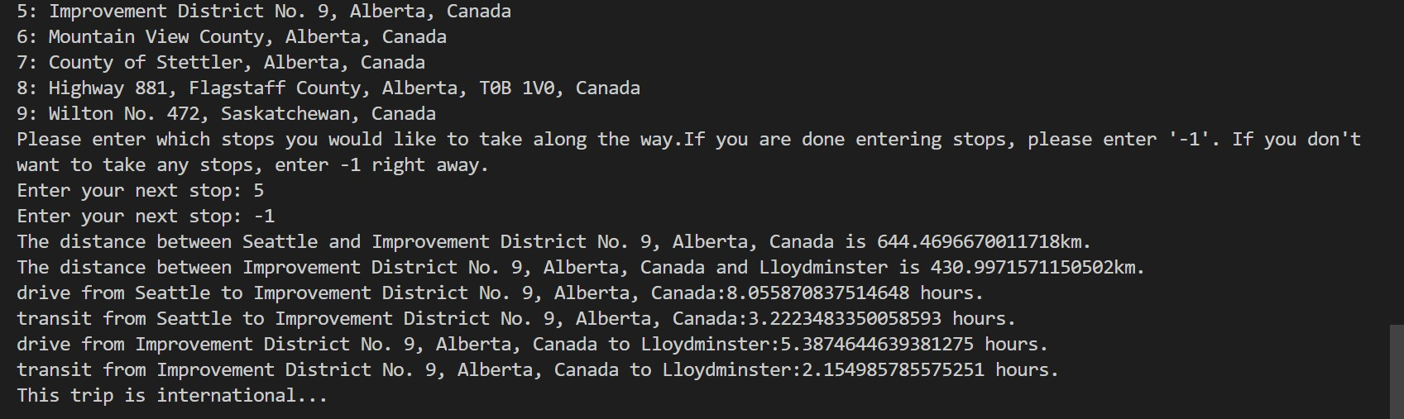

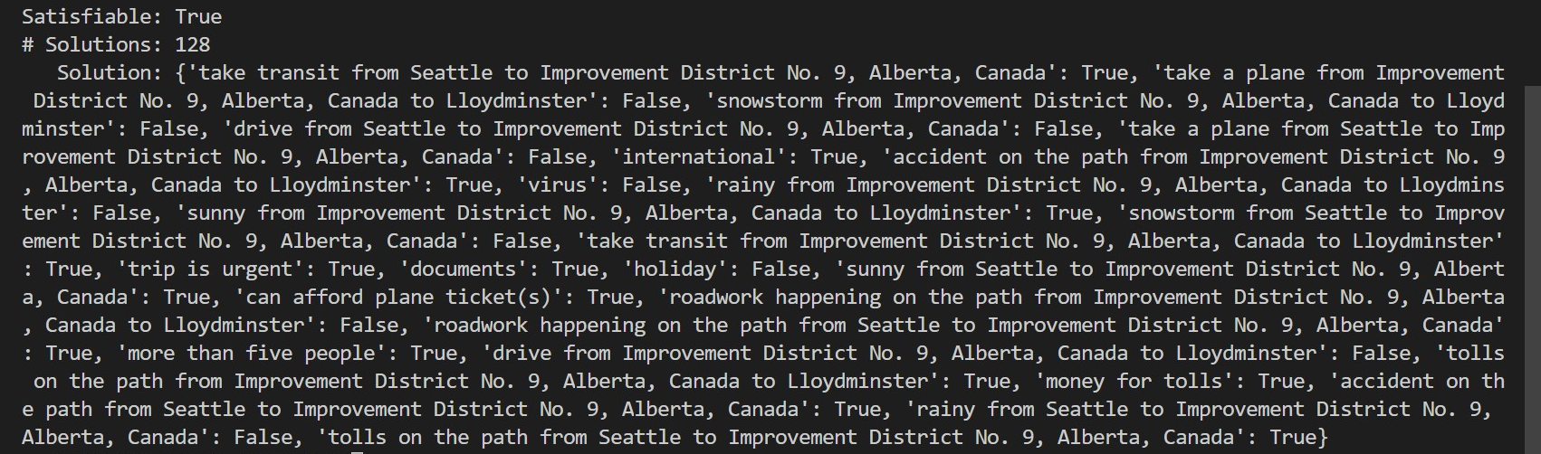

* When we first started out our project, we initially came up with 4 cities- 2 in Canada and 2 in the United States- that we would use to model our project with. At this stage, we did not have user input so we were going to model the possible solutions for transportation between all 4 cities. It quickly became apparent that without grouping the propositions together in some way, this was incredibly inefficient, as the only way to test constraints was to do so manually for each city. We also really didn’t like how not robust the model was and how everything felt really contrived and “hard-coded.” (We began thinking about putting the cities in some sort of array, which got us to thinking – if we could gather cities in an array and test the constraints in a loop, couldn’t we do to this for as many cities as we want? This led us to expanding our model to all of Canada and the United States – more on this later).

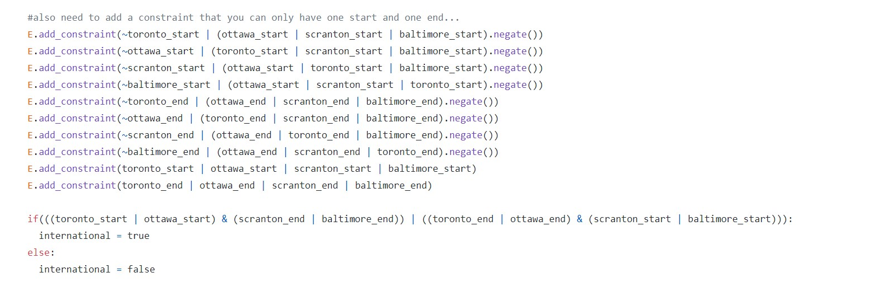

* Something else interesting to note is that when we started out this assignment, we did not understand that if a constraint failed (that is, the propositions did not match to the specifications of a constraint), the whole model would be tossed away. As a result of this misunderstanding, we ended up implementing a separate “fail” variable where each of the constraints implied “fail.” Then, we added a final constraint that fail had to be false. Once we realized that this system was automatically implemented for us, we were able to completely get rid of the fail variable and our code worked exactly the same.

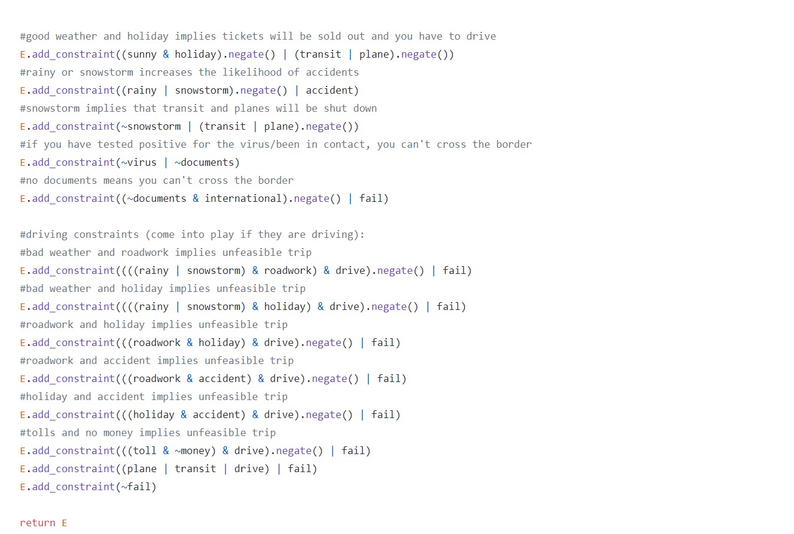

* In the early stages of our model, we also only had one of each proposition, so they would be spread out across all locations. Logically this didn’t make a lot of sense as, for example, there could be an accident from Toronto to Scranton but not from Toronto to Ottawa. This would be remedied soon…

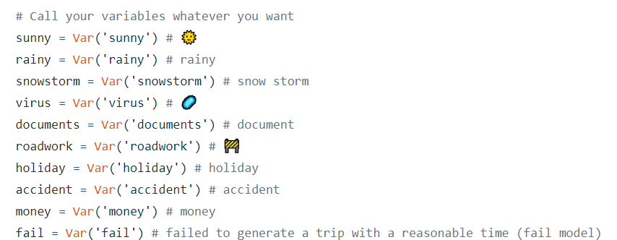

* We also did not immediately realize that for certain propositions such as weather and transportation, we needed to ensure that not only did the existence of one proposition negate the other, but that exactly one of them had to be true. For example, we initially had this for weather:

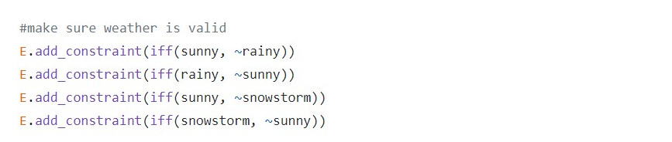

While this ensured that sunny and rainy/snowstorm could not both be true at once, the SAT solver still generated models in which no weather propositions were true at all. That also meant that any constraints caused by weather would not be relevant in those models, resulting in way more solutions than we needed.

There is another problem with these constraints that we did not notice until far into our updated model. For some reason we believed that we should use an if and only if here, when in fact it is not necessarily true that, for example, when it is not rainy then it must be sunny. Here is an example of the error:

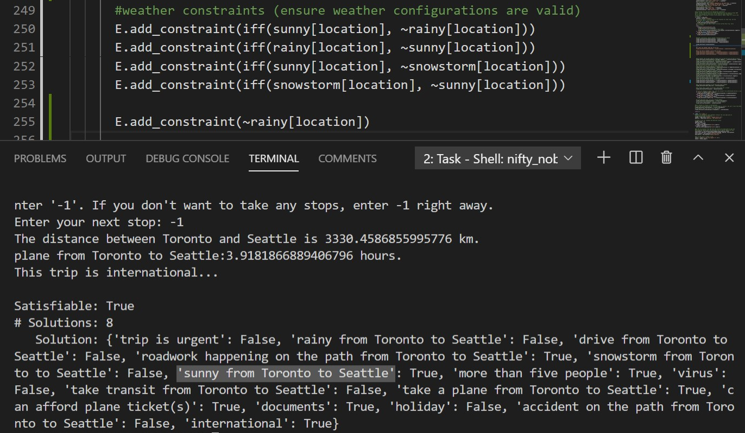

The interesting thing is that these incorrect constraints both resulted in more solutions (as there was the option that no weather was true in a model) AND less solutions as it not being rainy implied that it was sunny, when in fact there could be a snowstorm instead. Since the error was “levelled off” it flew under the radar for longer than it should have. Going forward we ensured to test constraints more rigorously. Here is the correct version of the weather constraints. You can see that now, forcing rainy to be false still allows for snowstorm to be true:

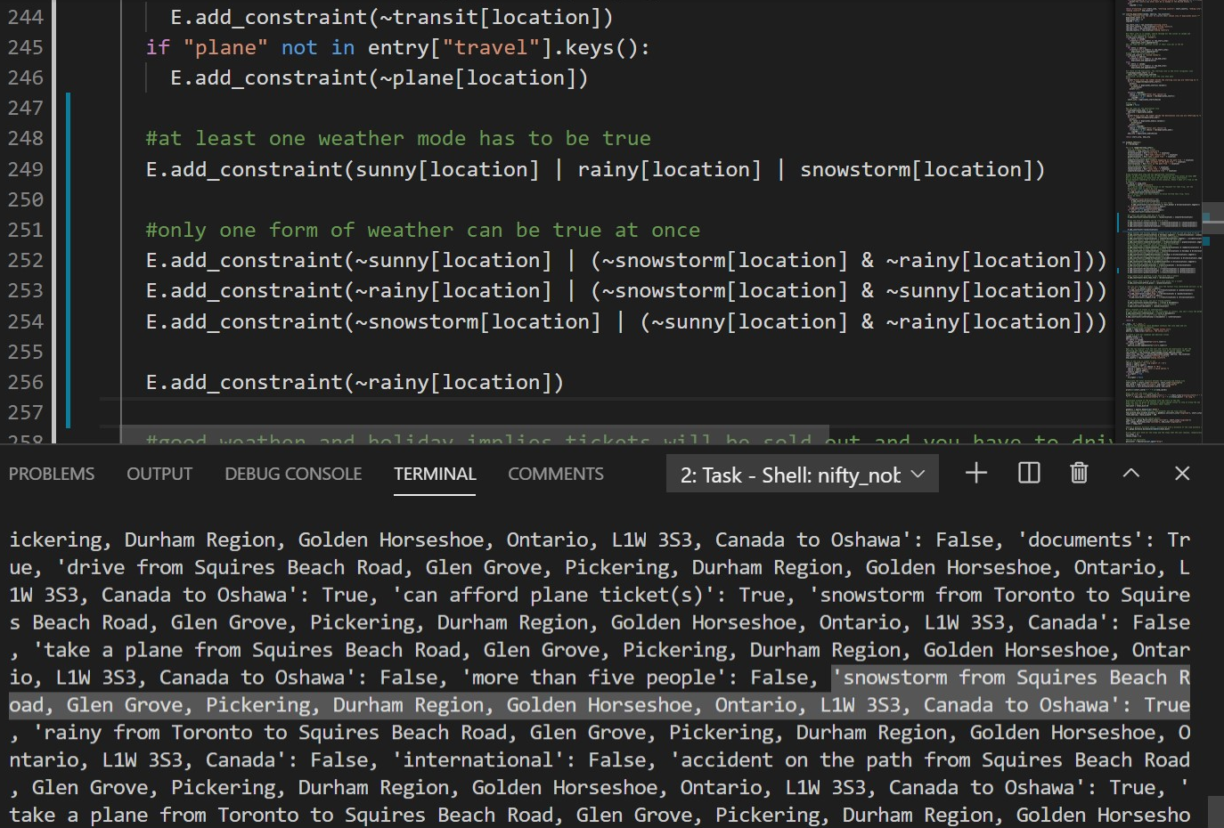

The exact same constraints are used for our modes of transportation.

* As mentioned before, the biggest change to our model was when we incorporated a database of U.S. and Canadian cities instead of using 4 hard-coded cities. This was a drastic change as it completely changed how we had to define our propositions and constraints. Before, we only had one proposition for all 4 cities, but we realized that to make a sensical model we would need propositions for each stop. The amount of propositions would also have to be dynamically sized to the amount of stops that the user picked. So, we ensured to collect user input **before** setting up the model and finding solutions, then used the list of locations to initialize all of these propositions:

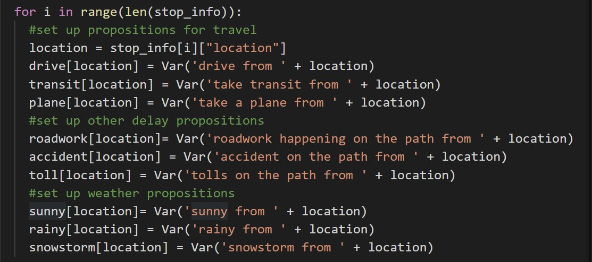

This was a major breakthrough as the SAT solver would have to work a lot harder now to take into consideration all of these propositions for **each** stop! This also made the model much more dynamic as now we could have, for example, tolls and snowy weather from stop 1 to stop 2, while stop 2 to stop 3 needed a plane so no snowstorm could be present, etc.

Note that some propositions stayed “universal,” as in, they don’t change based on the location (holiday is one such example).

* One way that we tested the travel propositions/constraints was to ensure that only feasible modes of travel were possible. One way that we did so was to enter two cities that were very far apart and try to force the mode of transportation to be transit (not possible), or to do so with cities that were very close together and try to force the mode of transportation to be plane (also not possible). Here are a couple examples, where we attempt to take transit from Toronto to Seattle and attempt to take a plane from Toronto to Oshawa:

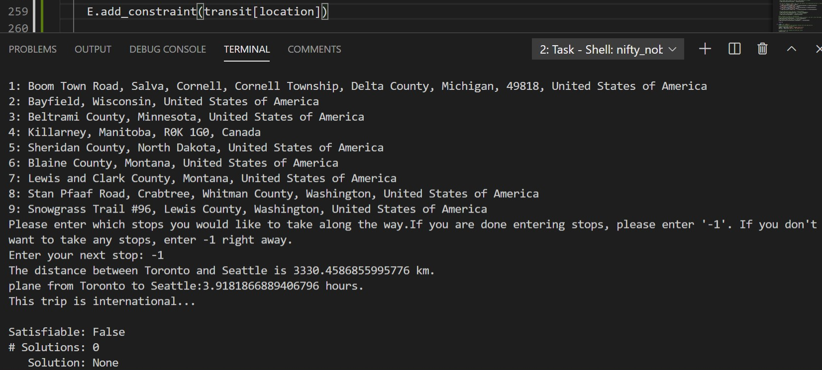 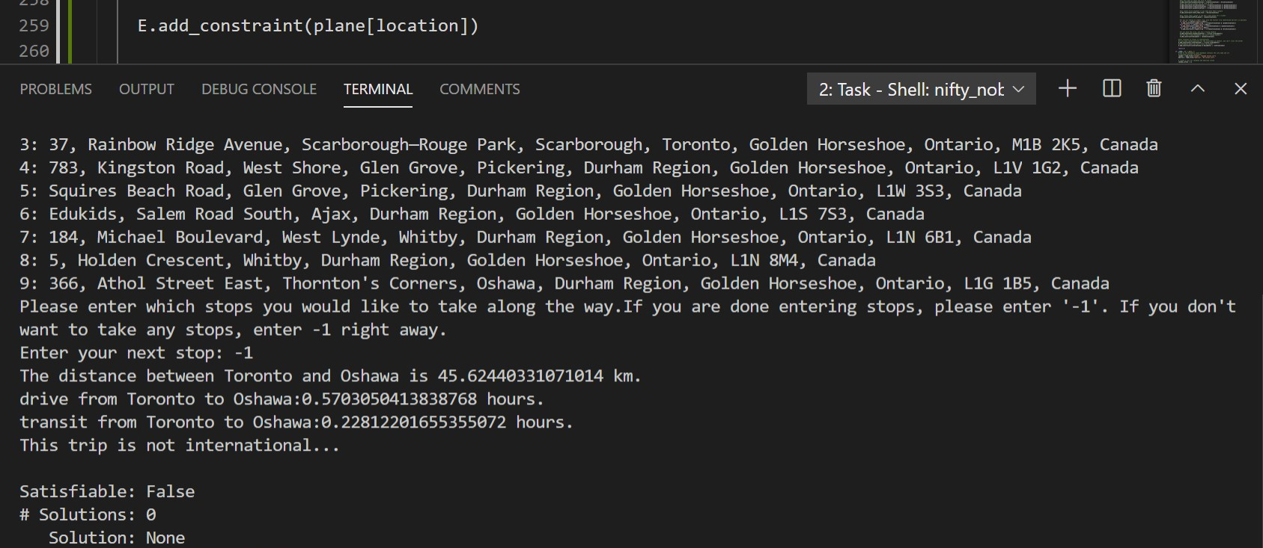

* Another way that we tested our constraints was to ensure that when multiple propositions in a constraint would force a result (for example, sunny and holiday means that you couldn’t take transit), if one of the propositions (one of sunny or holiday) was true and the consequent (not taking transit) was false, then the other proposition in the antecedent must be false. In simpler terms, if there was a holiday and the model indicated that transit was being used, then it must be true that it is not sunny. **This is also the basis of one of our proofs.** Here is an example of us testing that constraint, using our first testing function:

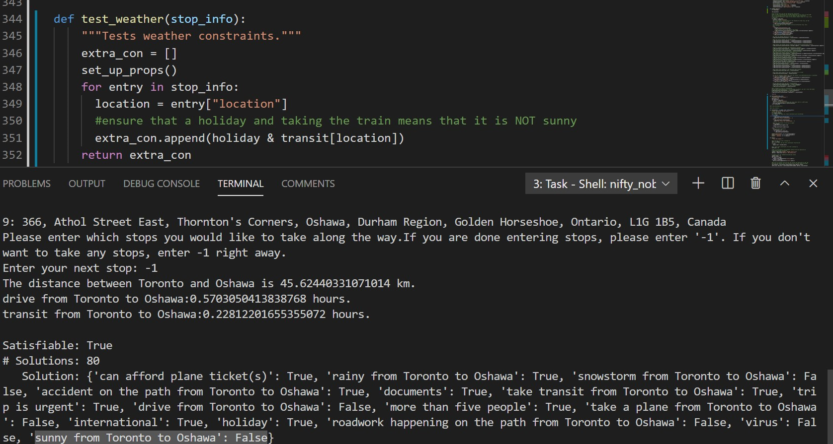

We then added onto our testing function by forcing snowstorm for that location to be false (that way transit can always be true, as a snowstorm would be the only other proposition preventing it). If our understanding of our model is correct, then by proxy rainy for that location should be true (as at least one type of weather must be true). To ensure that rainy is true, we can check that accidents for that location are also true. (If we forced accidents to be false, we should then get 0 solutions). We test this assertion with the following updated function and see that it is correct:

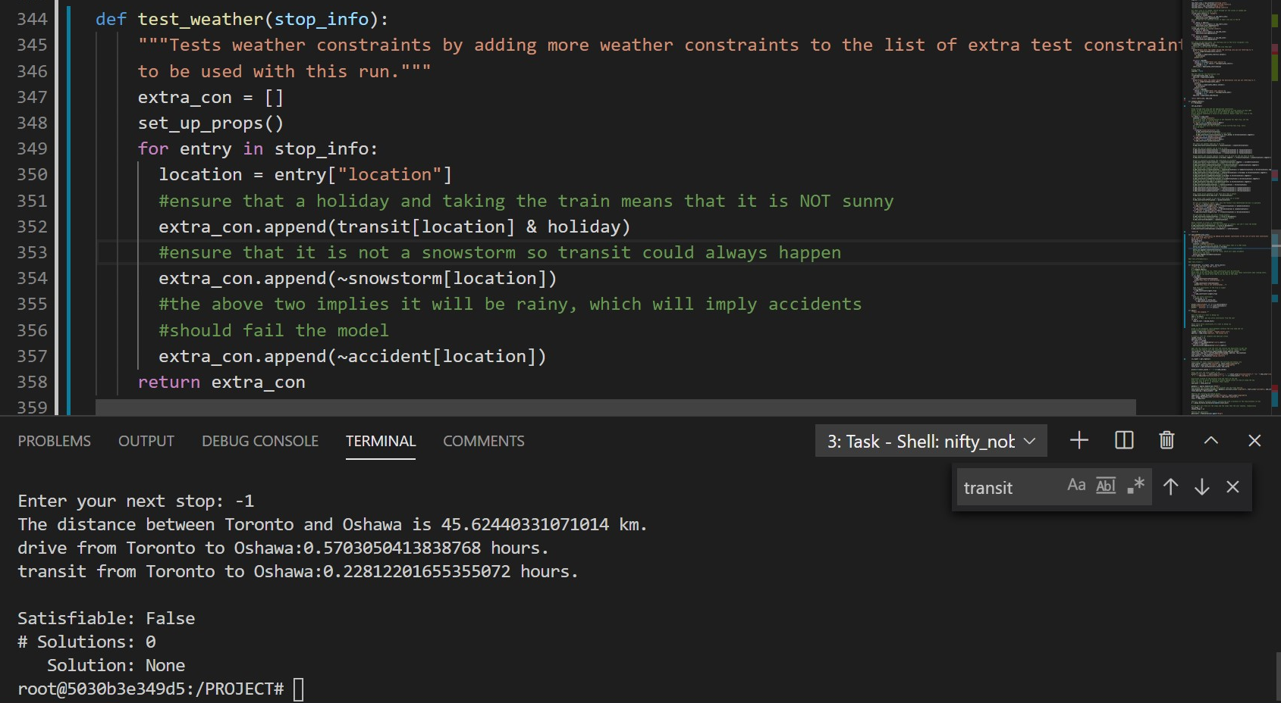

In summary, this testing function ensures that the effects of weather on other propositions are exactly what we would expect.

* Our next testing function examines the effects of affordability. We force international to be true so there will be toll money, then force the user to not be able to afford a plane and have no toll money. The result is that their only option is take transit, or the model fails. For a trip from Toronto to Milwaukee with multiple stops, transit was available:

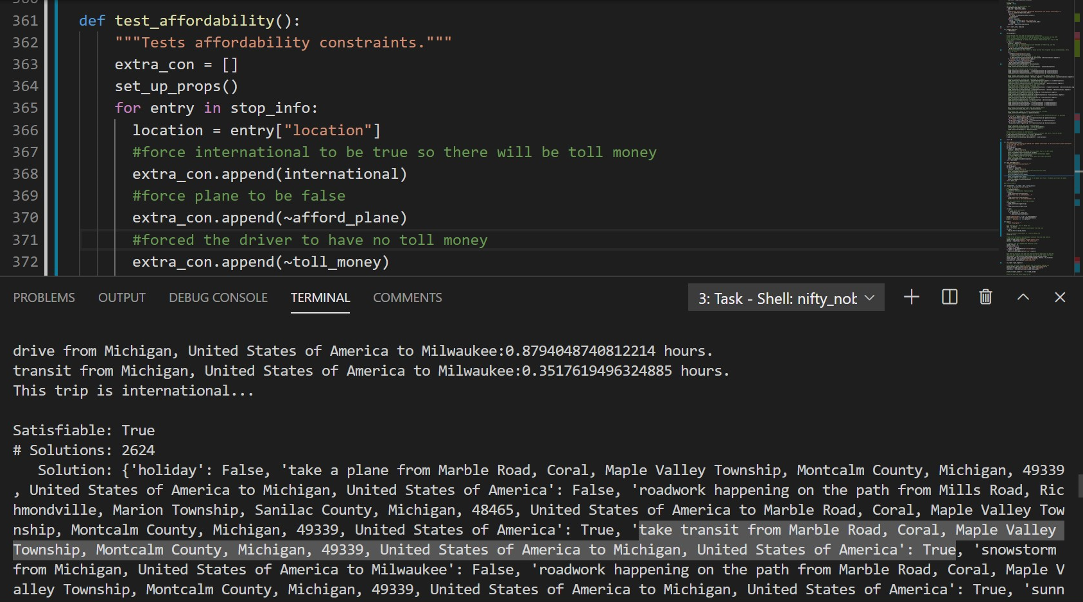

A trip from Toronto to Phoenix with no stops obviously wouldn’t have a single transit route, however, so the model fails as expected. We can solidify the assertion that this will always happen by forcing transit to always be false and always getting 0 solutions, as no mode of transportation will be available. Below is the same example from above, using a trip from Toronto to Milwaukee with multiple stops:

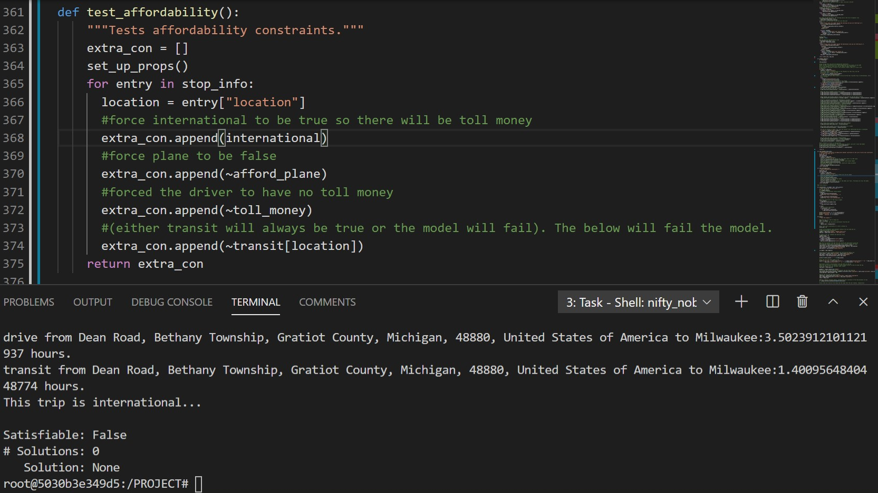

* Finally, for our last testing function, we test the effects on travel constraints. We force there to be more than 5 people taking the trip, then assert that they have COVID. As a result, they cannot drive or take a plane and they can only travel domestically. The model should fail if the user supplies an international trip or otherwise tries to go farther than they could possibly go with transit. Here is what happens if the user attempts to travel from Toronto to Seattle:

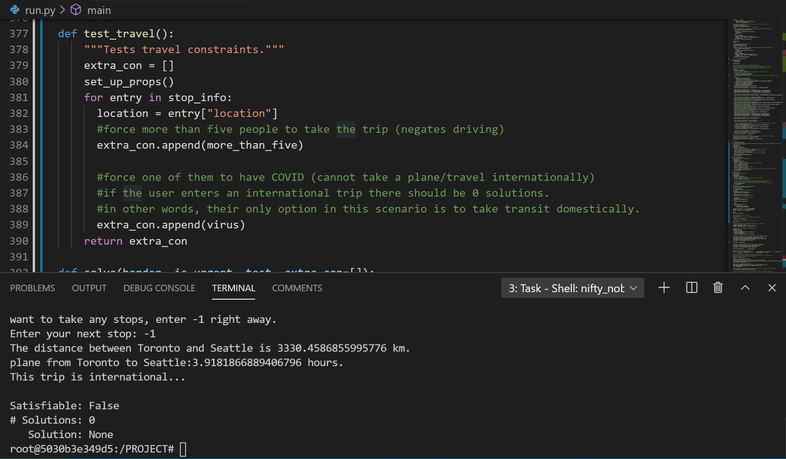

If they attempt to travel domestically (Toronto to Calgary) but we hardcode the negation the option of transit, we will also have 0 solutions; as no mode of transportation will be available.

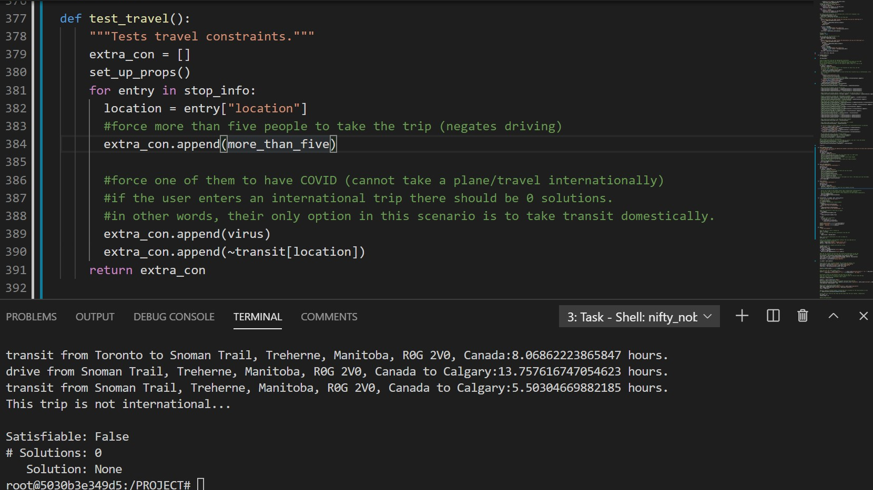

* We took a few extra considerations after reading feedback on our model. That included implementing the more_than_five and afford_plane propositions as well as the urgency proposition. The most interesting of these is the urgency proposition, which forces a model to take the fastest route. The model fails if the fastest route is not possible. We ensured that the urgency proposition drastically affected the model by seeing what happened when we forced it to be true or false:

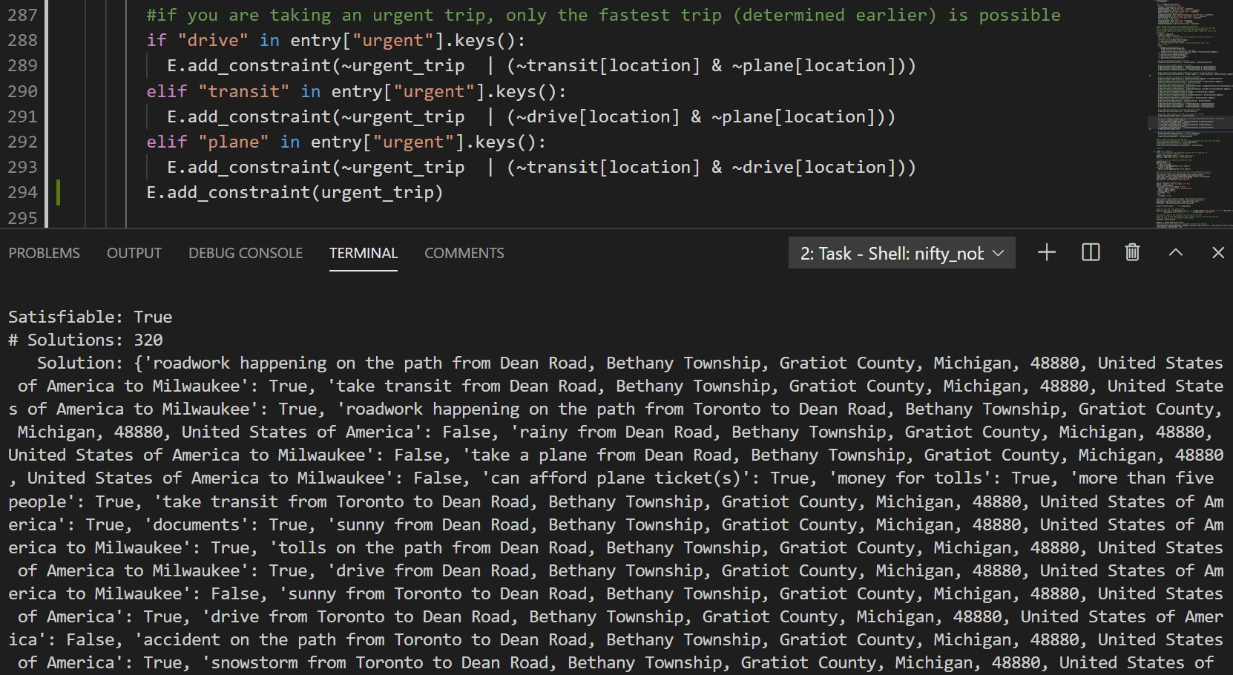

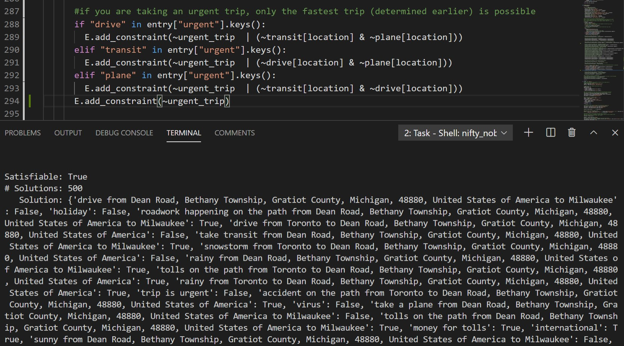

You can see that the not urgent trip has many more solutions as many more modes of transportation are viable.

**First-Order Extension (Update)**

Predicate Logic: For each proposition, we can represent it with a predicate that holds a starting location i and an ending location j. The universal discourse *A* is the cities in Canada and the US. This is demonstrated as shown in the followings:

Sunnyi,j = Sunny(i,j) Drivei,j = Drive(i,j)Roadworki,j = Roadwork(i,j)

Rainyi,j = Rainy(i,j)Transiti,j = Transit(i,j)Accidentsi,j = Accidents(i,j)

Snowstormi,j = Snowstorm(i,j) Planei,j = Plane(i,j) Tolli,j = Toll(i,j)

**All the above constraints that use these propositions could be replaced with their predicate counterparts, using universal quantifiers to refer to all locations i and all locations j**; for example,

∀i∀j Sunny(i,j) ∨ Rainy(i,j) ∨ Snowstorm(i,j).

Below are some possible additional constraints that use predicate logic and could be used in an expanded model:

* ∀i∃j (D(i,j) ∧ M(i,j) ∧ ¬I): For all starting locations i, there exists an ending location j where you can drive from i to j, and you have to pay toll money from i to j and the trip is not international. Basically, what this shows is tolls should always be considered a trip is made, either domestically or internationally. **M = toll money, I = international**
* ∀i ¬∃j (D(i,j) ∧ (T(i,j) ∨ P(i,j)))
* ∀i ¬∃j (T(i,j) ∧ (D(i,j) ∨ P(i,j))) Only one form of transportations can be true at once while travelling from
* ∀i ¬∃j (P(i,j) ∧ (T(i,j) ∨ D(i,j))) one location i to another location j (re-model of our current constraint).
* ∃iAj(¬T(i,j) ∧ ¬P(i,j)): There exists a starting location i where for all ending locations j, you could not take transit or a plane. This is not modelled in our project, but this could be true for a very small, isolated town. We would like have to import a separate database of what modes of transportation were available in each city.
* ∀i∀j((F ∧ U ∧ I) → P(i,j)): **(F = more than five, U = urgent)** For all starting locations i and all ending locations j, if you are travelling with more than 5 people and the trip is urgent and international, the most sensible option would be to take a plane.
* ∀i∀j(U ∧ D(i,j))→ ¬(A(i,j) ∨ C(i,j) ∨ B(i,j))): **(U = urgent, A = accident, C = construction (roadwork), B = blizzard (snowstorm))** For all starting locations i and all ending locations j, if the trip is urgent and being made by car, there cannot be any one of accidents, roadwork, or a snowstorm during that trip as that would significantly slow down the trip. This could be implemented if our model made use of a time system, where a trip had to be made in a certain amount of time.
* ∃i∃j(F ∧ H)→ ¬D(i,j) ∧¬T(i,j) ∧¬P(i,j)): **(F = more than five, H = holiday)** There exists a starting location i and there exists an ending location j, where if you are travelling with more than five people and it is a holiday, no mode of transportation will be possible. Having more than five people automatically negates the ability to drive. In this scenario, the existence of a holiday could sell out all train and plane tickets regardless of good weather (for example, in a COVID scenario where people don’t care about weather and just want to return to their hometown/visit family). This could also apply to a scenario where both cities have big populations and traffic would be heavy regardless.

**Jape Proofs Notes**

**Note that the propositions used refer to ONE set of locations, so i,j are omitted.**

1. This is a preliminary proof that we will use as a premise in the following proof. The idea is that if you are not driving from one location to another and at least one form of transportations is true for a correct model, then it implies that you either take a transit or a plane from one location to another.

**D = drive, T = transit, P = plane**

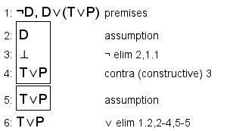

1. The idea is that: if you have more than five people, it implies that you can’t drive from one place to another. Since at least one form of transportations needs to be true for a correct model, we can imply that either transit or plane is true. Then, if holiday is true and we know that good weather (sunny) and holiday imply that you can’t take transit or plane. Therefore, the logical conclusion is if we are taking transit or plane and it is during a holiday, it means that it can’t be sunny.

**D = drive, T = transit, P = plane, F = more than five people, H = holiday, S = sunny**

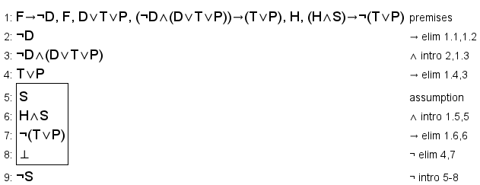

1. This is another preliminary proof that will be used as a premise in the following proof. The idea is that exactly one state of weather must be true when travelling from one location to another. Given that, if there is no snowstorm and it is not sunny, that implies it has to be raining for a true model.

**S = sunny, R = rainy, B = blizzard (snowstorm)**

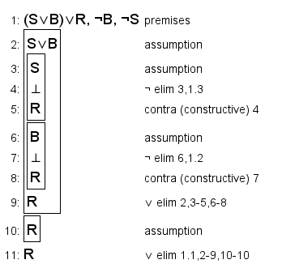

1. Since we are taking a plane during a holiday, it cannot be sunny. There cannot be any snowstorms since we are taking a plane. Given that exactly one state of weather has to be true for a correct model, and neither sunny nor snowy are true, it implies that it is rainy. Rainy weather implies accident. So we can deduce from the premises that there was an accident

**S = sunny, R = rainy, B = blizzard (snowstorm), P = plane, H = holiday, A = accident**

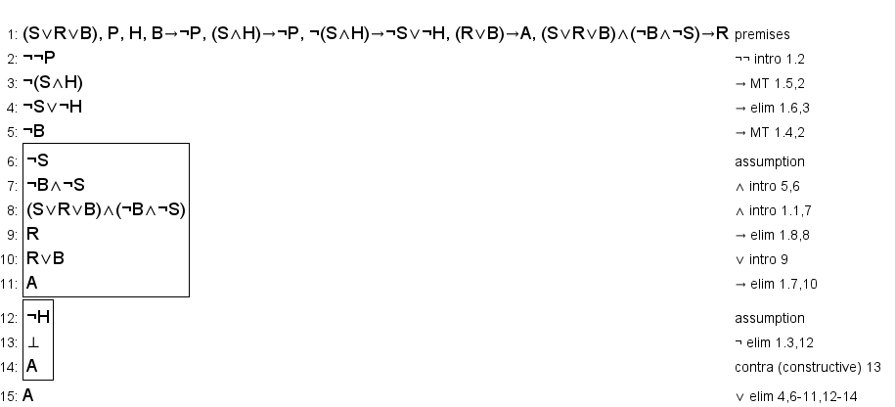

1. Given that you are positive to COVID-19 (virus), this means that you can’t cross the border (can’t travel internationally). If there is a snowstorm, that means we cannot take a plane or transit. A snowstorm also increases the likelihood of an accident. Since there is a roadwork (construction) and the chances of an accident happening is very likely, it means that you cannot drive.

**R = rainy, B = blizzard (snowstorm), A = accident, G = germs (virus), Q = qualifications (for travelling INTERNATIONALLY), C = construction (roadwork), D = drive, T = transit, P = plane**

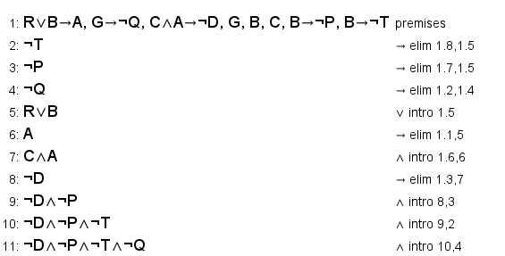

**External Libraries in the Model**

* **Geopy:** included in the calc_distance function, where we calculate the distance between two locations using latitudes and longtitudes.
* **Pyproj (Geod):** included in main, where we calculate the initial bearing and final bearing. The bearings will vary depending on the starting/ending locations and their latitudes/longtitudes.
* **Nominatim:** define the geolocator in main()